**Karan Arora**  **R.L. Institute M: 9416974837**

**Max Time : 1 ½ hr** **Class = 12th Biology Test**  **Max Marks : 40**

**PRINCIPLES OF INHERITANCE & VARIATION**

1. Multiple choice questions : [ 1 X 10 = 10]
2. Condition of a karyotype 2n + 1 , 2n –1 and 2n + 2 , 2n –2 are called

|  |  |  |  |
| --- | --- | --- | --- |
| a) Aneuploidy | b) Polyploidy | c) Allopolyploidy | d) Monosomy |

1. A dihybrid cross between homozygous round yellow (RRYY) and wrinkled green (rryy) seed varieties of pea was traced through two generations. The possibility of genotype RRyy in F2 generation should be as :

|  |  |  |  |
| --- | --- | --- | --- |
| a) 1/16 | b) 2/16 | c) 3/16 | d) 9/16 |

1. Genes regulating many phenotypic characters are called :

|  |  |  |  |
| --- | --- | --- | --- |
| a) Complementary gene | b) polygenic trait | c) pleiotropic gene | d) Multiple allele |

1. Pentasomic can be denoted by :

|  |  |  |  |
| --- | --- | --- | --- |
| a) 2n + 2 | b) 2n + 3 | c) 2n + 1 | d) 2n + 4 |

1. ZZ/ZW type of sex determination is seen in

|  |  |  |  |
| --- | --- | --- | --- |
| a) Platypus | b) Snails | c) Cockroach | d) Peacock |

1. Which of the following represents a pair of contrasting traits

|  |  |  |  |
| --- | --- | --- | --- |
| a) Alleles | b) Phenotype | c) Homozygous | d) Heterozygous |

1. How many different type of gametes can an organism of genotypes AaBBCc produce?

|  |  |  |  |
| --- | --- | --- | --- |
| a) 3 | b) 4 | c) 9 | d) 16 |

1. Mongolism or Down’s syndrome occurs when the patients have :

|  |  |
| --- | --- |
| a) 45 chromosome instead of 46 | b) 47 chromosome instead of 46 |
| c) 23rd chromosome in three doses | d) Non-disjunction of 21st chromosome |

1. ABO blood grouping is determined by three alleles. Possible genotypes and phenotypes are :

|  |  |  |  |
| --- | --- | --- | --- |
| a) 3 , 1 | b) 4 , 6 | c) 6 , 4 | d) 9 , 7 |

1. In maize, chromosome number is 2n = 20. The number of linkage group in it will be :

|  |  |  |  |
| --- | --- | --- | --- |
| a) 20 | b) 40 | c) 10 | d) 5 |

1. Who had proposed the chromosomal theory of inheritance? [ 1 ]
2. Define allele? [ 1 ]
3. Name the respective pattern of inheritance in which F1 phenotype does not resemble either of the two parents and is in between the two. [ 1 ]
4. Mention two genetic disorders with its symptoms? [ 2 ]
5. Difference between : [ 2 ]

(i) Dominanace and recessive alleles (ii) Homozygous and heterozygous

1. Study the figure given below and answer the question. [ 2 ]

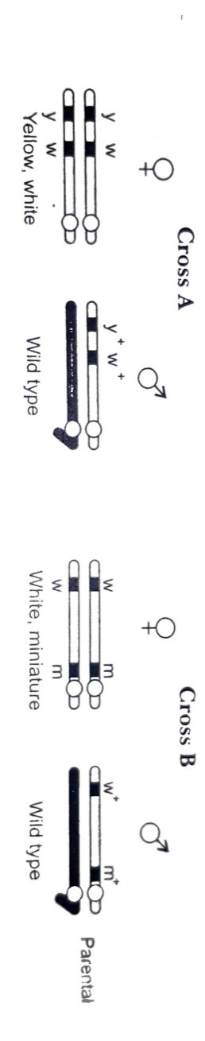

Identify in which of the following crosses is the strength of linkage between the genes higher. give reason.

1. Define and design a test cross. [ 2 ]
2. Study the pedigree chart showing the inheritance of haemophilia in a family. Answer the questions that follow: [ 2 ]

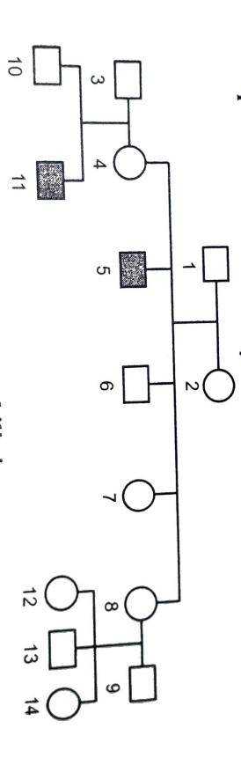

Give reason which explain that haemophilia is

(i) Sex-linked and (ii) caused by ‘X’-linked gene.

1. Explain the following terms with example [ 3 ]

(i) Co-dominance (ii) Incomplete dominance

1. Explain mechanism of sex determination in birds and humans [ 3 ]
2. (a) Explain the phenomena of dominance, multiple allelism and co-dominance taking ABO blood group as an example. [ 3 ]

(b) What is the phenotype of the following? (i) IAi (ii) ii

1. (a) State the law of independent assortment. [ 3 ]

(b) Explain pleiotropic gene with example.

1. (a) Write the scientific name of the organism Thomas Hunt Morgan and his colleagues worked with for their experiments. Explain the correlation between linkage and recombination with respect to gene as studied by them. [ 5 ]

(b) How did Sturtevant explain gene mapping while working with Morgan?

(c) In the given figure which of the following gene pair will show more recombination frequency? Give reason in support of your answer.

